**ICS 311 - Database Management Systems**

**Putty Installation**

Please follow the following steps in order to install Putty on your own system. This is the recommended step – it will allow you to use the student accounts setup on MSU servers.

Using any browser, go to [www.putty.org](http://www.putty.org). You can also use any other site where it allows to download it. This is a freeware software.

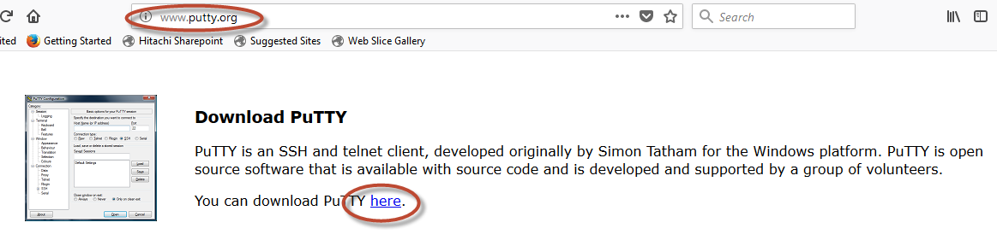

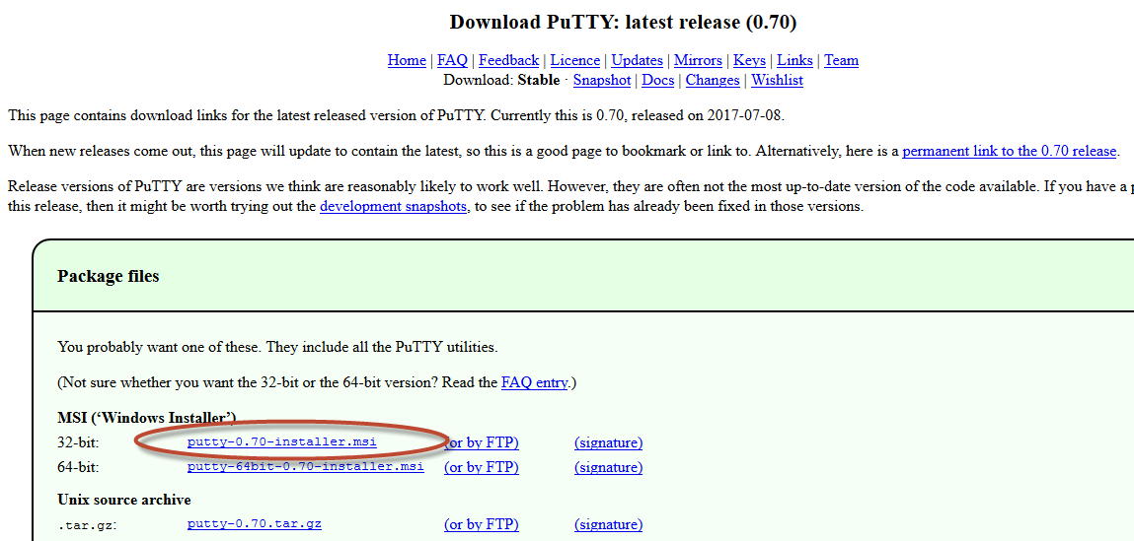

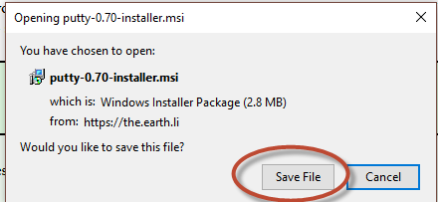

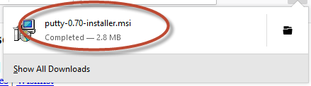

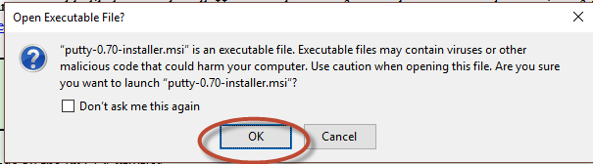

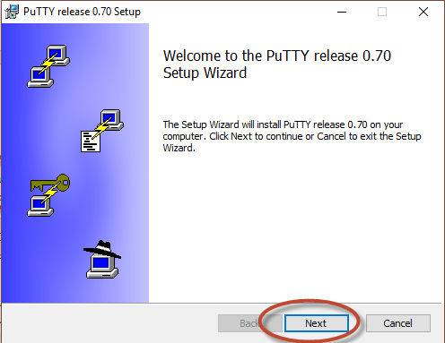

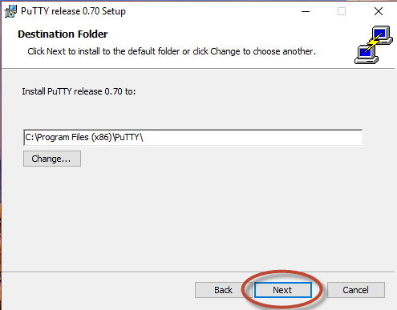

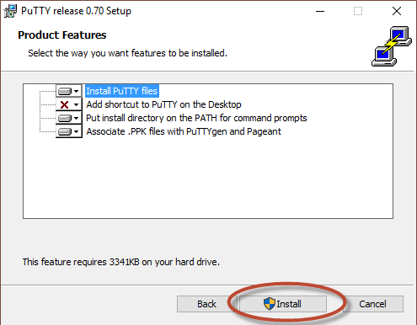

Once Putty is installed, double-click on the icon.

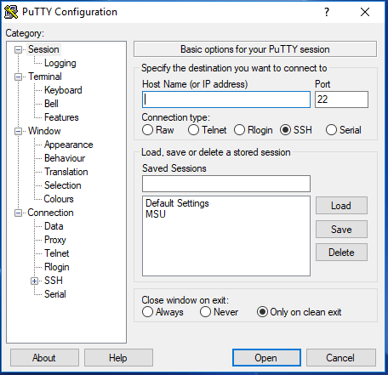

Enter sp-cfsics.metrostate.edu in the Host Name field

You can also save this information by providing a name in the ‘Saved Sessions’ field. This way, you will not have to remember the server name. Click on ‘Save’ button

Once saved, click on ‘Open’ button.

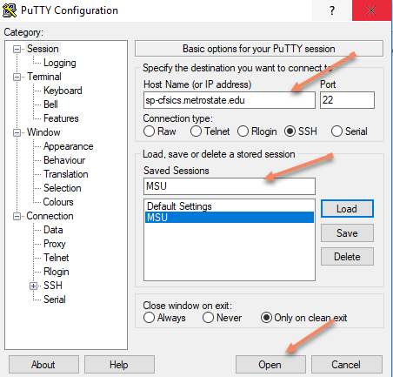

This will take you to the Putty screen with login prompt.

* + Use the sheet I provided with login information:
    - OS Username: ics311sp180201
    - OS Password:
    - DB Username: ics311sp180201
    - DB Password:
  + Enter OS Username as Login
  + Enter OS Password as password

You will now be logged into your Linux account.

To invoke MySQL;

mysql -u ics311sp180201 -p

Enter DB Password